# **Name: Abdurrahman Qureshi**

# **Roll No: 210451**

Practical No: 21

**1) Write a Program to display following output in browser Window.**

import java.io.*;

import javax.servlet.*;

import javax.servlet.http.*;

public class exp21q1 extends HttpServlet{

public void doGet(HttpServletRequest request,HttpServletResponse response) throws ServletException,IOException{

response.setContentType("text/html");

PrintWriter out=response.getWriter();

out.println("<html>");

out.println("<head>");

out.println("</head>");

out.println("<body>");

out.println("<h1>Welcome at Maharshtra Board of Technical Education!</h1>");

out.println("</body>");

out.println("</html>");}}

**OUTPUT:**

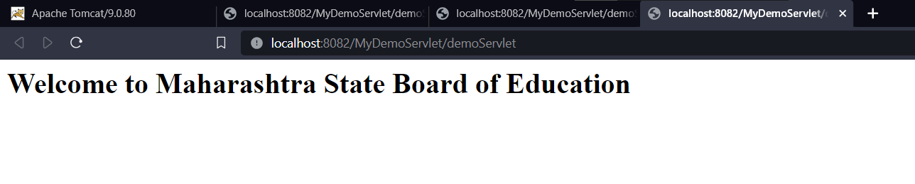

**2) Write the output of following code considering below HTML is front end and servlet as back end.**

**CODE:**

**Java Code:**

import java.io.*;

import java.util.*;

import javax.servlet.*;

public class exp21q2 extends GenericServlet{

public void service(ServletRequest request, ServletResponse response) throws ServletException, IOException{

PrintWriter pw = response.getWriter();

Enumeration e = request.getParameterNames();

while(e.hasMoreElements()){

String pname = (String)e.nextElement();

pw.print(pname + " = ");

String pvalue = request.getParameter(pname);

pw.println(pvalue);}

pw.close();}}

**Html code:**

<html>

<body>

<p>Enter Name:</p>

    <input *type*="text" *name*="" *id*="nameU">

    <p>Enter Password:</p>

    <input *type*="text" *name*="" *id*="passU"><br><br>

    <button *onclick*="submitData()">Submit</button

</body>

</html>

**OUTPUT:**

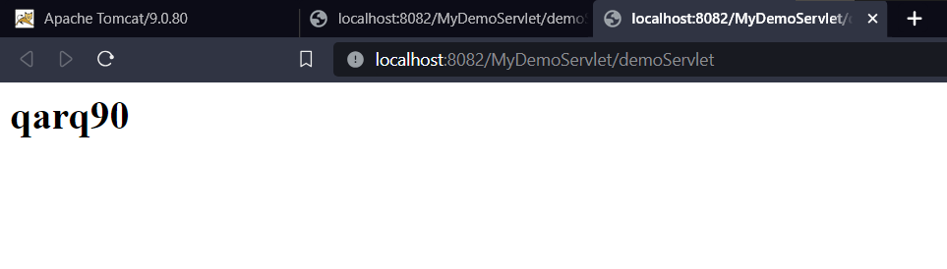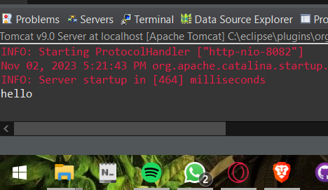

**3) Develop servlet program to print Hello MSBTE in browser window.**

**CODE:**

**Java Code:**

import java.io.*;

import javax.servlet.*;

import javax.servlet.http.*;

public class exp21q3 extends HttpServlet

{

public void doGet(HttpServletRequest request,HttpServletResponse response)throws ServletException,IOException

{

response.setContentType("text/html");

PrintWriter out=response.getWriter();

out.println("<html>");

out.println("<head>");

out.println("</head>");

out.println("<body>");

out.println("<h1>Hello MSBTE</h1>");

out.println("</body>");

out.println("</html>");

}

}

**OUTPUT:**

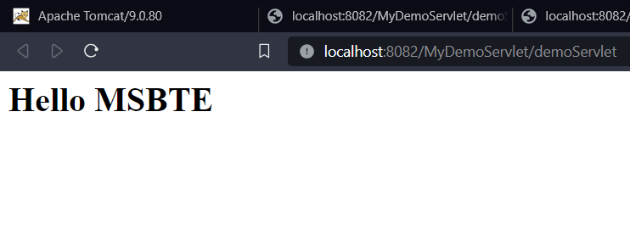

**4) Develop a program to receive the parameter through HTML forms and send back received parameter to browser.**

**CODE:**

**Java Code:**

import java.io.*;

import javax.servlet.*;

public class exp21q4 extends GenericServlet

{

public void service(ServletRequest req,ServletResponse res)throws ServletException,IOException

{

res.setContentType("text/html");

PrintWriter pw=res.getWriter();

String p1=req.getParameter("t1");

String p2=req.getParameter("t2");

if((p1.equals(""))&&(p2.equals("")))

{

pw.println("<h1>Fill the Fields</h1>");

}

else

{

pw.println("Welcome to Home Page!!!<br>You have entered ........ <br>userName="+p1+"<br>Password="+p2);

}

pw.close();

}

}

**Html code:**

<html>

<head>

</head>

<body>

<form action="exp21q4">

Name: <input type="text" name="t1">

Password: <input type="password" name="t2">

<input type="submit" value="Login">

<input type="reset" value="Reset">

</form>

**OUTPUT:**

